**DAILY ONLINE ACTIVITIES SUMMARY**

|  |  |  |  |  |  |  |  |  |
| --- | --- | --- | --- | --- | --- | --- | --- | --- |
| **Date:** | **23/05/2020** | | | | | **Name:** | **Shailashree** | |
| **Sem & Sec** | **IV sem & B section** | | | | | **USN:** | **4AL18CS077** | |
| **Online Test Summary** | | | | | | | | |
| **Subject** | | **Data Communication** | | | | | | |
| **Max. Marks** | | **30** | | **Score** | | | **25** | |
| **Certification Course Summary** | | | | | | | | |
| **Course** | **Introduction to Digital Marketing** | | | | | | | |
| **Certificate Provider** | | | **Great learning academy** | | **Duration** | | | **2.5 hours** |
| **Coding Challenges** | | | | | | | | |
| **Problem Statement:** Write a C Program to generate first N Triangular Numbers (Where N is Read from the Key board) | | | | | | | | |
| **Status: Executed** | | | | | | | | |
| **Uploaded the report in GitHub** | | | | | **YES** | | | |
| **If yes Repository name** | | | | | **Online-coding** | | | |
| **Uploaded the report in slack** | | | | | **YES** | | | |

Online Test Summary: 18CS46 test was scheduled from 9:15 am t0 9:55am. The portion for the IA was 1st module and 2nd module there were 30 questions and the time assigned was 30 minutes the questions were mcq type.

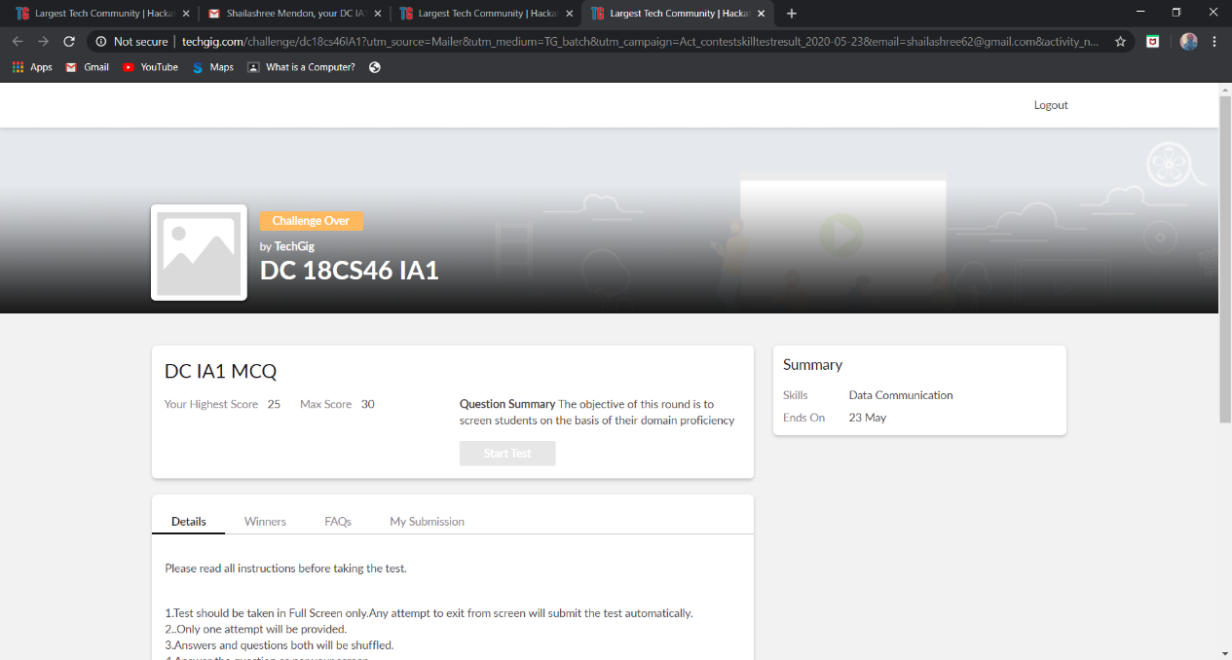

The above snap shot is the completion of the test and the marks allotted.

Online Certification Course Summary: Today I have learnt about purpose of using Facebook as a marketing channel and also about Facebook interface and types of audience and how to set up a Ad in Facebook what are the steps to be followed to create a business page in Facebook and also learnt how to view the audience who have visited the page and also about custom audience.

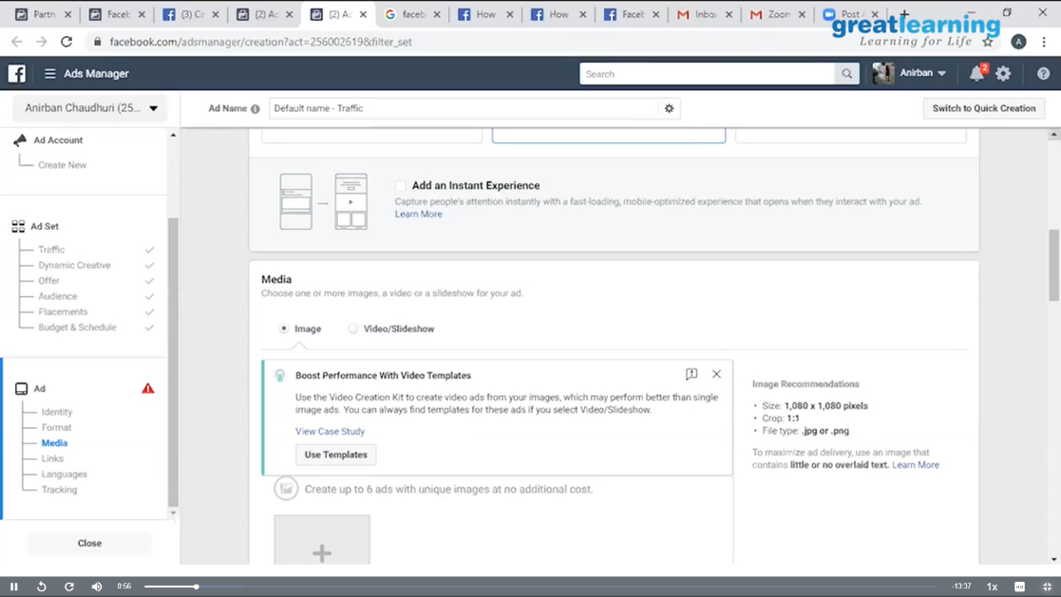

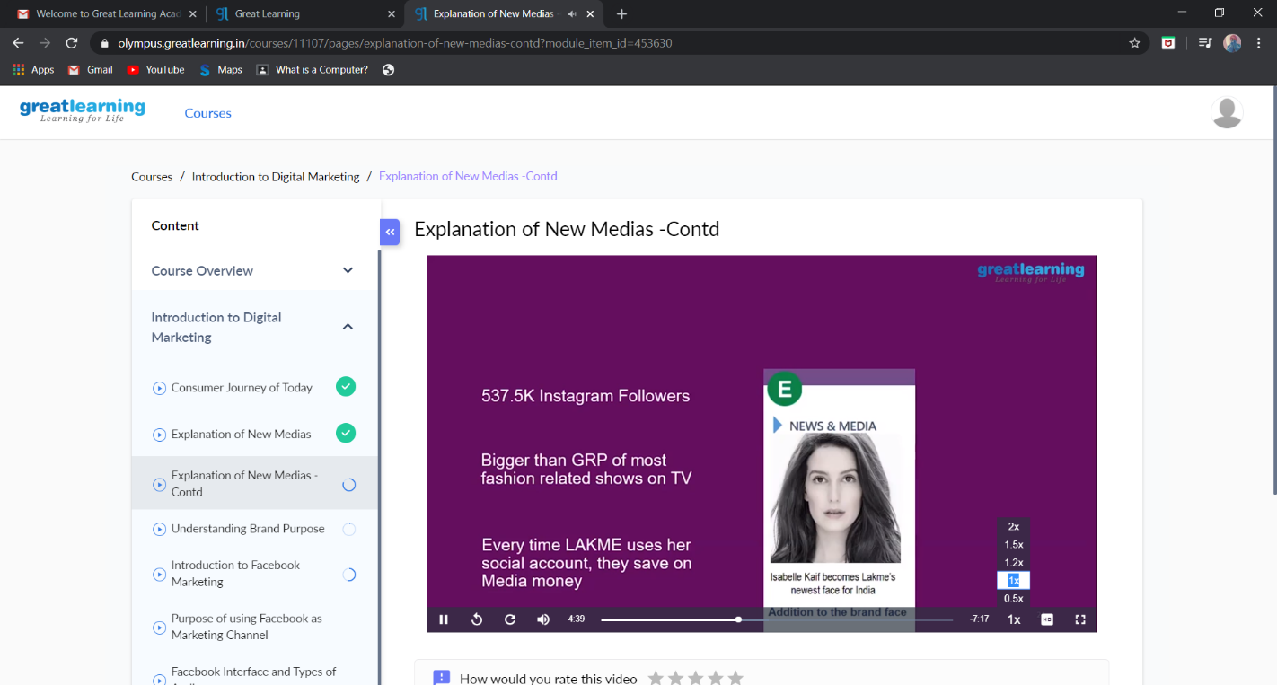

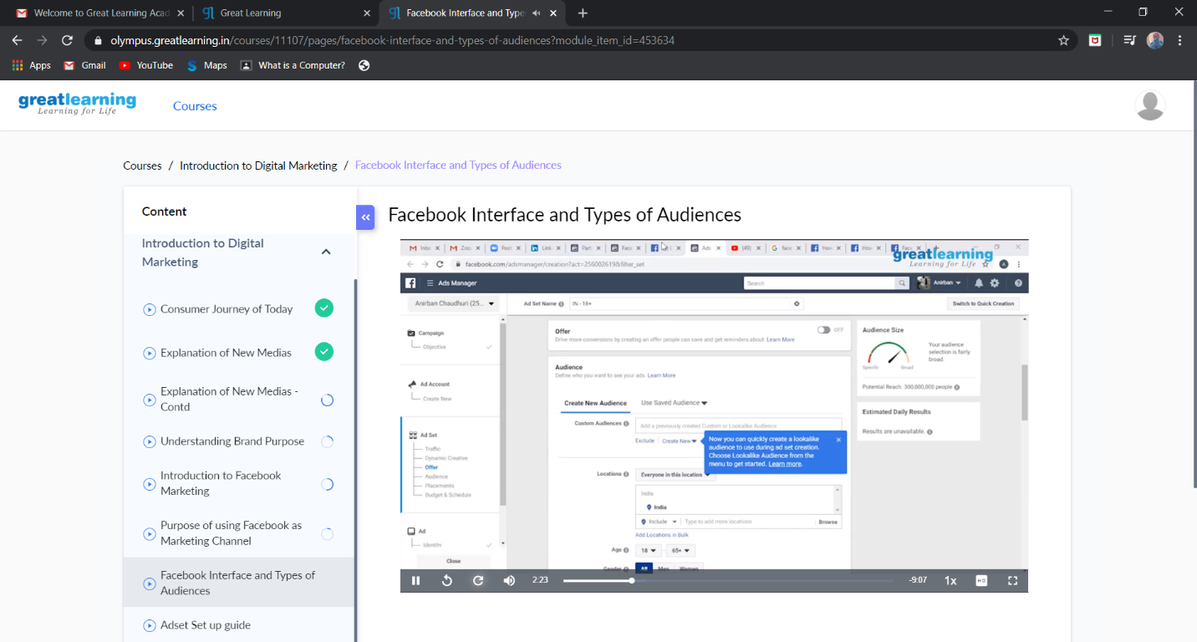

These are the snap shots of today’s session.

Online Coding Summary: **Today I had received one program from prof.Venkatesh CSE Dept. The programs is mentioned above in the coding challenges(pg.01). I have also uploaded it to my GitHub repository.**

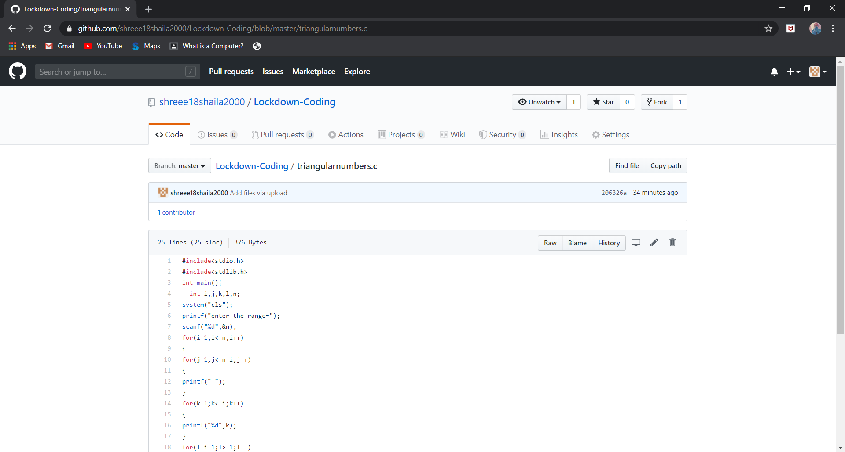

It is the snap shot of my repository were I have uploaded the code. File name is triangularnumbers.c